**Front End/UI Bugs/Fixes**

**General:**

1. Registration - Would like the welcome email to not be sent to the users account.
2. General Responsiveness: on small screen like 14" laptop screen is not good for Finder Tool and Mail section.

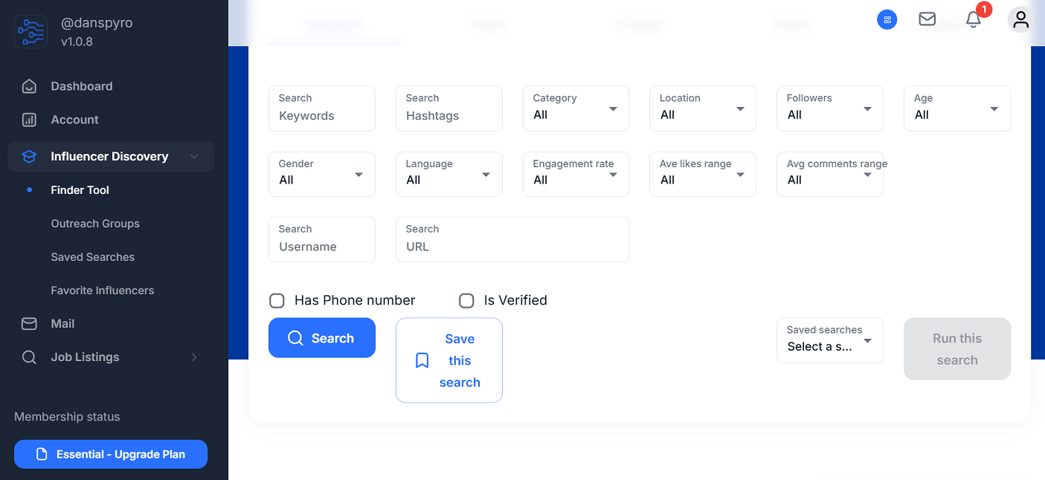

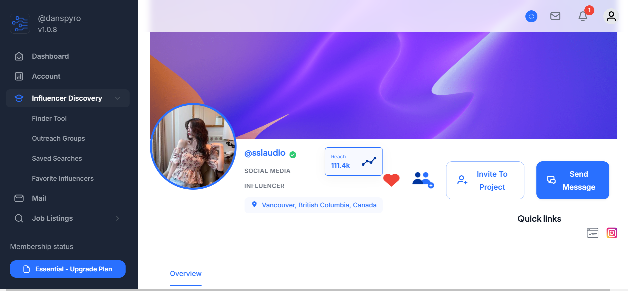

1. Left Side bar - Icons aren't evenly spaced/padded. When the user logs in, Influencer Discovery and Job Listings should have the sub links auto opened (currently they're closed by default). The link will still be visible if the user wants to close it.

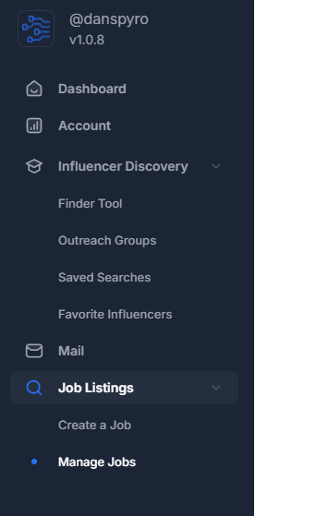

1. Top Side bar - Icons aren't evenly spaced/padded. Notifications Icon and Messaging Icon are not working for New Messages. Unsure if all the others are working.

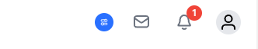

1. Brand Profile - When clicking my Profile link, nothing appears, white screen.
2. Dashboard - Individual blog post should have the images auto sized so they’re all the same size and the titles of each blog post should be all aligned on the same line/row. The height should be much higher than what’s current.

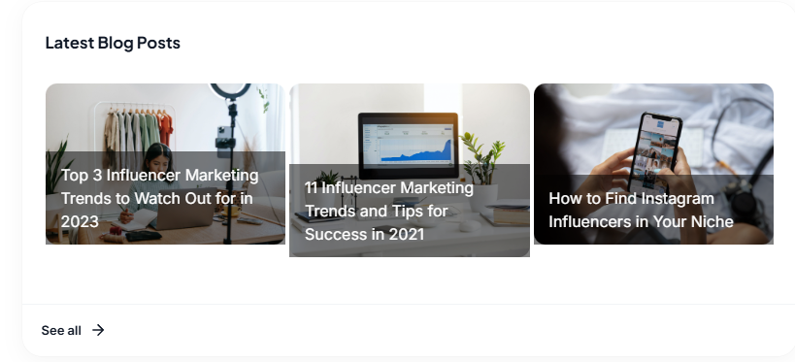

Below is dev, the height and look should appear similar, plus the images working.

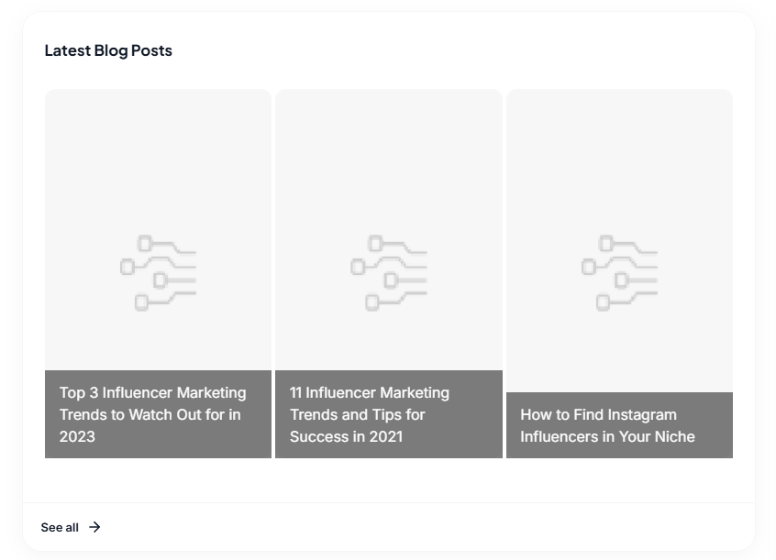

1. Account - Billing - Change plan - Stripe, in dark mode, the font is black so you cannot see the credit card numbers, should be white in dark mode:

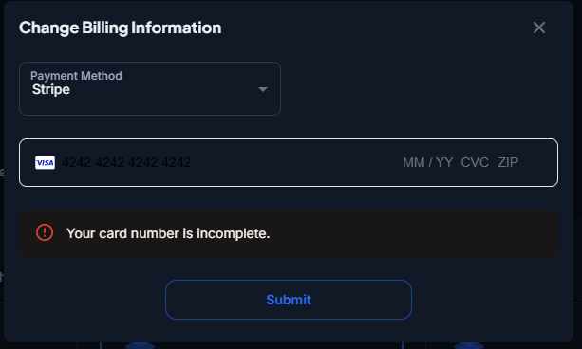

**Influencer Discovery -> Influencer Tool:**

1. When the page loads, all Influencers should appear but only showing the top 10. When the user begins using the tool and searching, that’s when the credits begin kicking in for each subscription. Currently, they have to hit search to view anything, would like to eliminate this. This issue is intermittent, it worked once for me randomly after a new account was created and opening the tool the very first time.

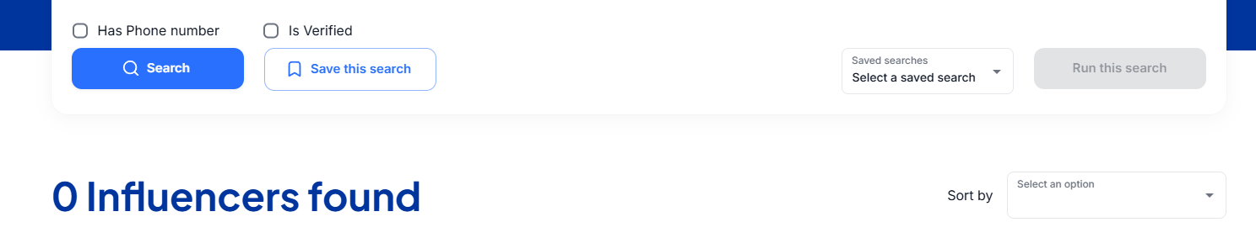

2. Sort By: Select an option - filter drop down, it shows blank. It should auto select the default (Follower count - High to low)

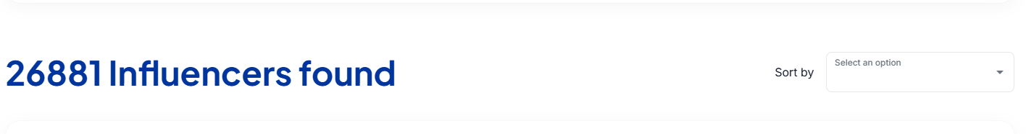

**Mail:**

Inbox:

1. The design in dark mode has some issues, for eg, the username under inbox is the same color as the dark mode background so you cannot see the font.

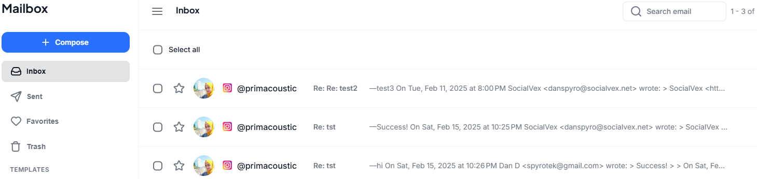

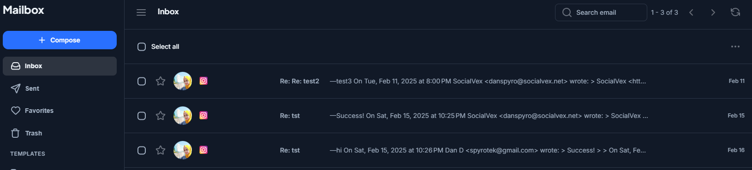

1. When you select a message with the checkmark, a trash icon should appear to delete it, that doesn't seem to be working or appearing. This actually doesn't work for all links - Inbox, Sent, Favorites, Trash. The icon and development works but you have to click the three dots and then delete, the icon should auto appear as well

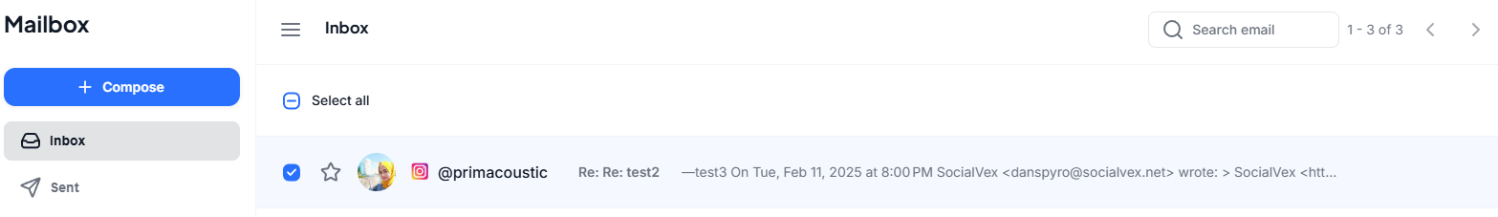

1. Message - I believe we need a few changes. When multiple emails are sent/received with the same recipient, the format should just show one entry in the inbox and when you click it, you see all of the historical messages, Exactly like gmail. Also the emails sent and received are off, its sent in an odd format with a big grey and white box vs transparent, like gmail, can this be changed?

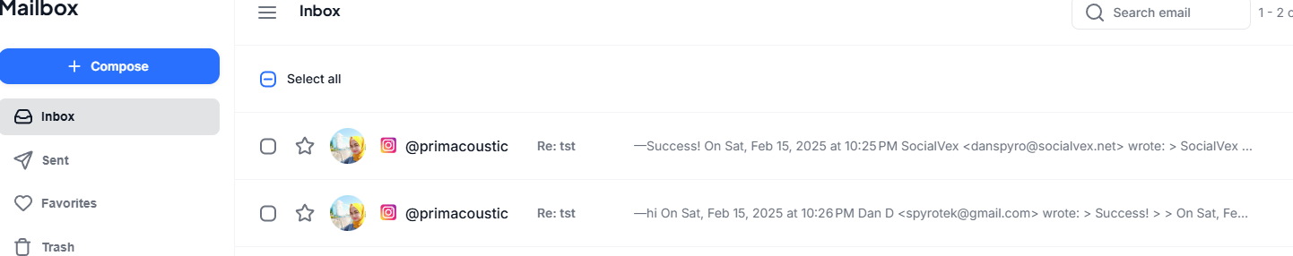

Should be grouped when sent/received with same recipient, ie:

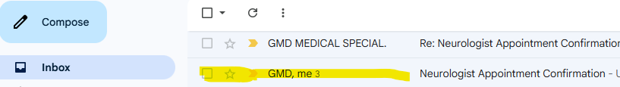

The messages should look clean, like an email,. This is how emails are received when sent from the platform, which needs a UI redesign and change.

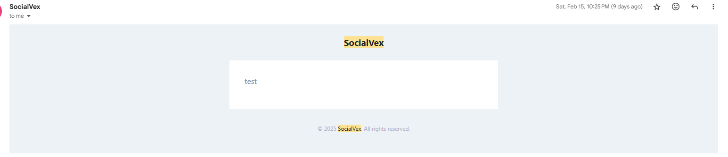

4. I tested some emails/messages. When a new message appeared in the users inbox, when I clicked on it, I got a blank screen. Tried 5 times. The 6th time, then the email appeared. maybe a bug?

5. Email priorities - Under all 4 links again (Inbox, Sent, Favorites, Trash), the latest to oldest appears bottom to top. It should be like all email clients, the most recent should appear at the top of the list, not the bottom.

6. New Templates/New Emails - The icons dont seem to be functioning - image, link, enoji.

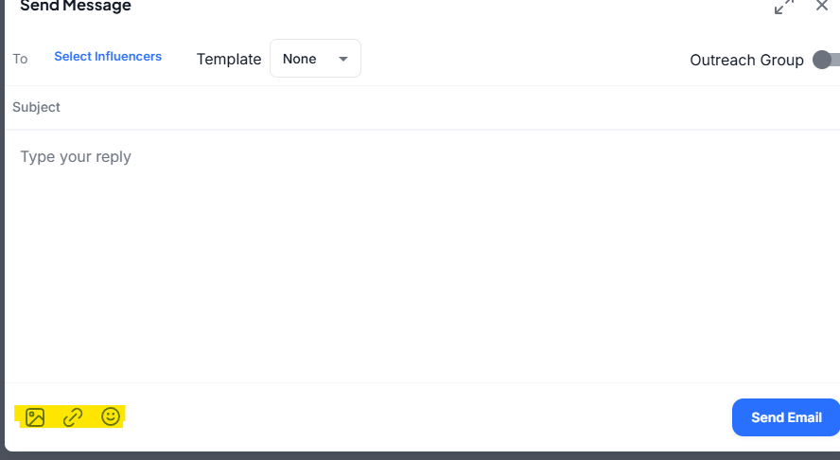

8. Sent - Sent items sometimes dont appear and a couple messages tested are exposing the server IP instead of showing the influencer account.

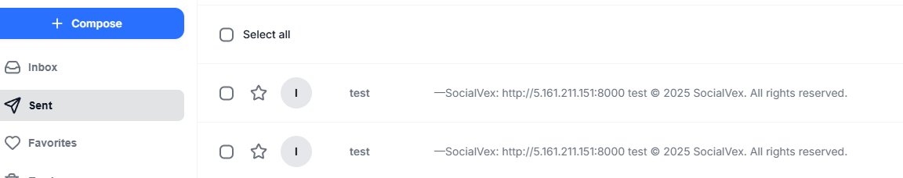

**Create job ad**

1. At Step 5: Share - The favorites are all showing null(instagram) instead of the actual accounts which are favorited. When I click Skip, it auto defaults to All which sends the invite to all Favorites and all Outreach Groups. This will need fixing as I'm unable to select No Favorites or No Outreach Groups

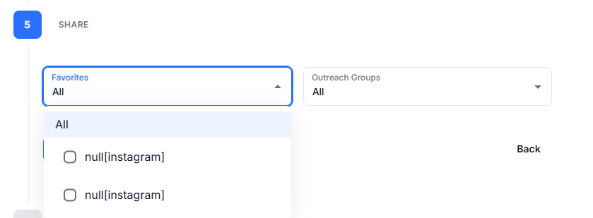

1. When you click Manage Jobs and then Manage on the active job, it shows some default job above the headlines with a default title which says "Instagram Influencer for a clothing brand who can market our products for a week". This section should be removed.

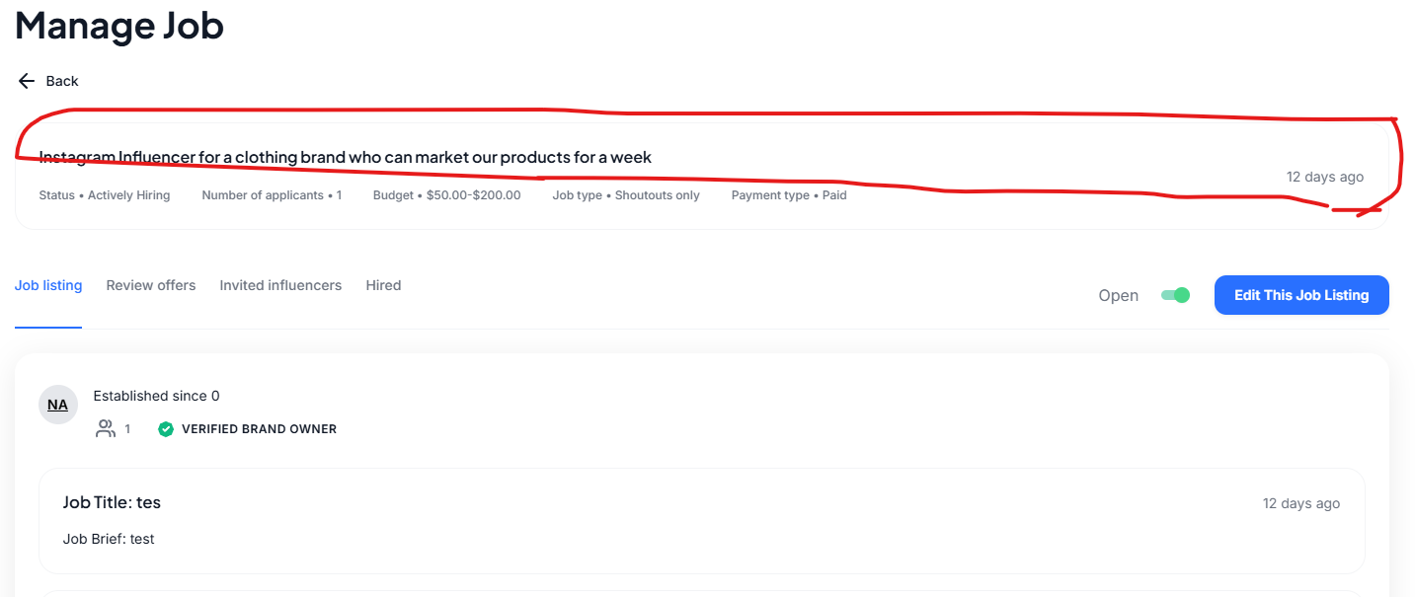

3. Notification for job offer - It shows the job offer but the link it broken. Notification also doesn’t go away after clicking. The email notification didnt work for a new job applicant.

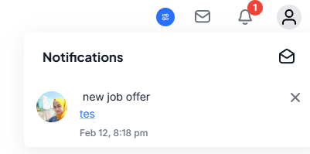

Job Listings

1. Manage job - Review Offers - View Messages - this button doesnt work.

